**Lab Terminal**   
 

**Submitted By :Nida Eman**

**Reg No: fa21-bcs-002**

**Submitted to : Sir Bilal Haider**

**Course: Compiler Construction**

**Date: 3/1/2025**

**Qs 3: Optimization Example in MiniCompiler.**

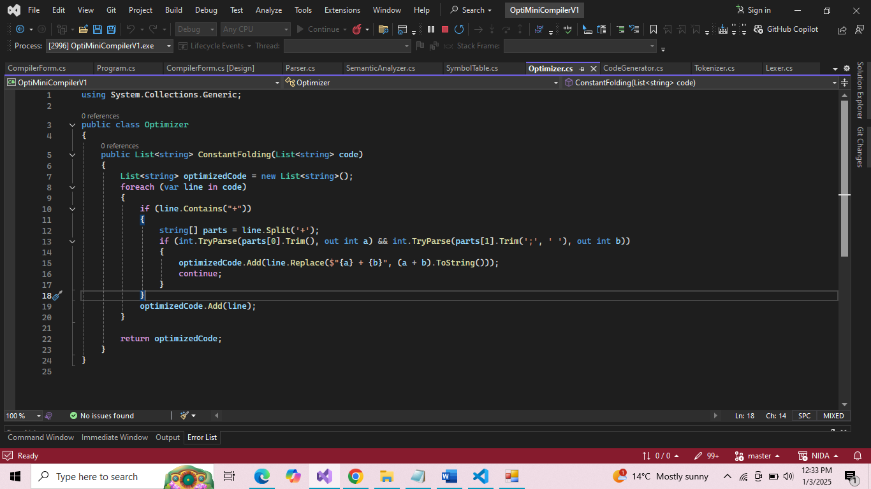

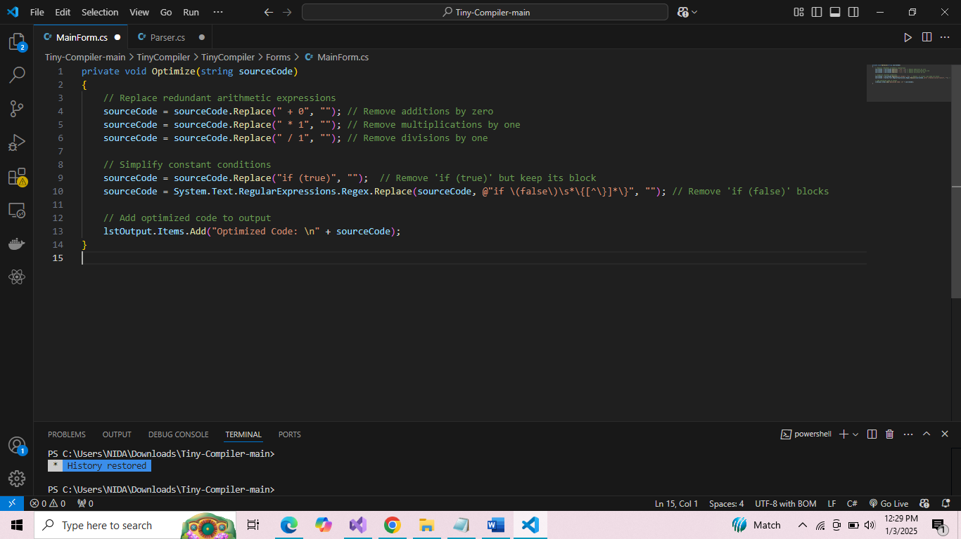

Ouput:

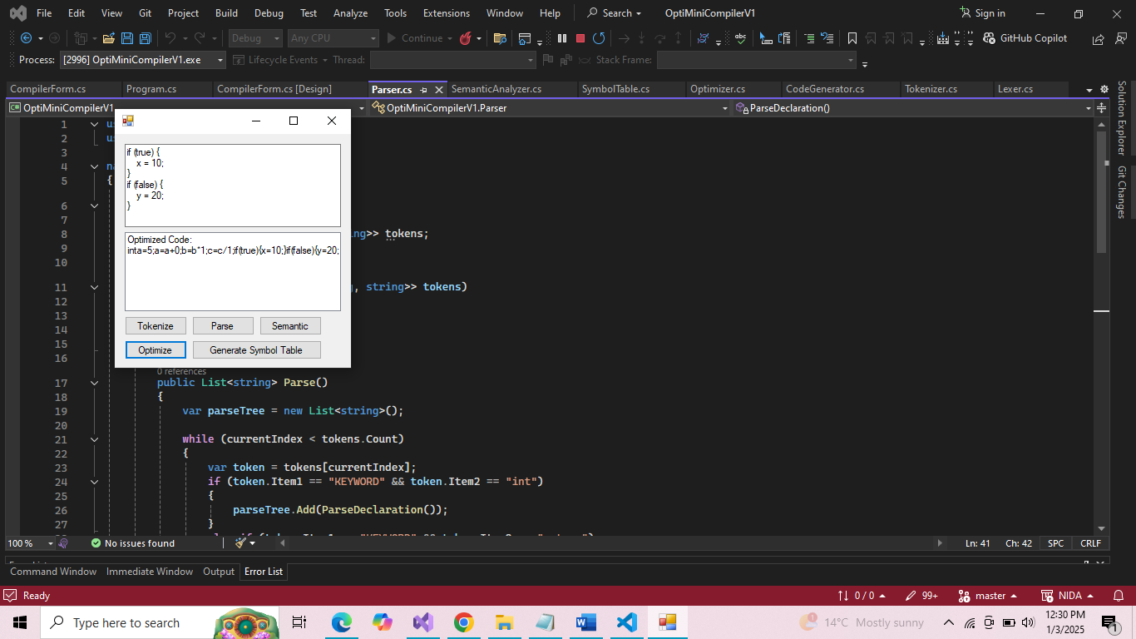

**Steps for Optimization**

**Remove Redundant Arithmetic Operations:**

* Replace a = a + 0; with a; because adding zero does not change the value.
* Replace b = b * 1; with b; because multiplying by one does not change the value.
* Replace c = c / 1; with c; because dividing by one does not change the value.

**Constant Condition Simplification:**

* Remove blocks with constant false conditions (e.g., if (false) is skipped entirely).
* Include blocks with constant true conditions (e.g., if (true) is always executed).

**Dead Code Elimination**

* Remove unreachable or unnecessary code.